NHB+ Point of View Process

The Mental Box Exercise

Who’s box are you in?

The brain is a meaning making machine, but it can’t create meaning without comparison.

Because you have to separate things and differentiate them.

Once it separates things, then it joins them and combines them into MEANING, this is the generalization process.

When you listen to certain people that have a certain energy about them, you can feel that you and everyone else is in their box.

Box can be a symbolic representation of “reality”, so THEIR reality.

When Eminem raps everyone is in his box

When I market everyone is in my box

Because in that box you are the best otherwise how can it be your box?

If you’re in someone else’s box they’re better than you

Point of View Process

If their safety and security and status, survival and reproduction is attached to it, don’t break the POV directly, go easy.

Everyone is focused on attention

But it doesn’t matter what attention is

What you do with attention is what matters most

If you know how to do this, you can have a very very very small audience and make big big big money

So the people that are focused on attention, they have this weird ratio of a lot of attention, but not enough money.

Awareness
-> Contrast (doing things / talking about things that are different out there)
-> Controversy (debate between people and they agree / disagree)
-> Attention (focus over time)
-> Point of View (this changes the value and perception of education, sale, and the close, and their worldview. This is what really allows you to be in control of the sales process) ->
-> Motivational copy (you get them to be motivated in order to be educated. You’re basically selling the value of education).
->Education (the reason being is that educated customers have the highest AOV. Why? Because they have assessed the most risk and are willing to pay more, the less riks, the more they’re willing to pay. This is the reason webinars worked so well, they’re VERY educational).
Sale (selling them on the concept - deciding value)
-> Close (deciding trade offs) ->
-> biggest mastermind in the game

Marketing is change work.

- We change opinions, feelings, biases, views, etc…

Education -> this is where we do the change work
- FB group
- FB wall
- Twitter
- Email list
- SMS
- Webinars
- Calls
- Stage
  - So when I speak on stage, I change the point of view of the audience
- Anything where they gather around you to listen

The human brain can only focus on one thing at a time.

Diet:

- Keto
- CICO
- Carnivore
- Intermittent fasting
- Vegan
- Paleo

Make money online

- Copywriting
- Media buyers
- CRO
- Offer Owners
- Sales
- Closing
- Email Marketer
- Dark Lording

What the POV process does is looks at one thing and causes it to become favorable over others.

Let's say I was a VEGAN guru. I would use this to make VEGAN the #1 category in their mind.

Without the POV process, you have interference as to what you’re selling.

POV process is a mechanism in the brain and once you know how the mechanism works you can use it vs allowing it to just operate on its own.

Attention in isolation (focus over time) -> Data in the environment (if you can change the environment, you can control the data) -> Deletes -> Distorts -> Generalizes -> TRUTH (once it accepts something as true, it stops seeking the truth).

Human brain operates through sensory mechanisms: eyes, ears, nose, touch, taste

It will use these 5 senses and then gather data.

What do you see, what do you hear, what do you smell, etc…

This is why we need to include this in openings.

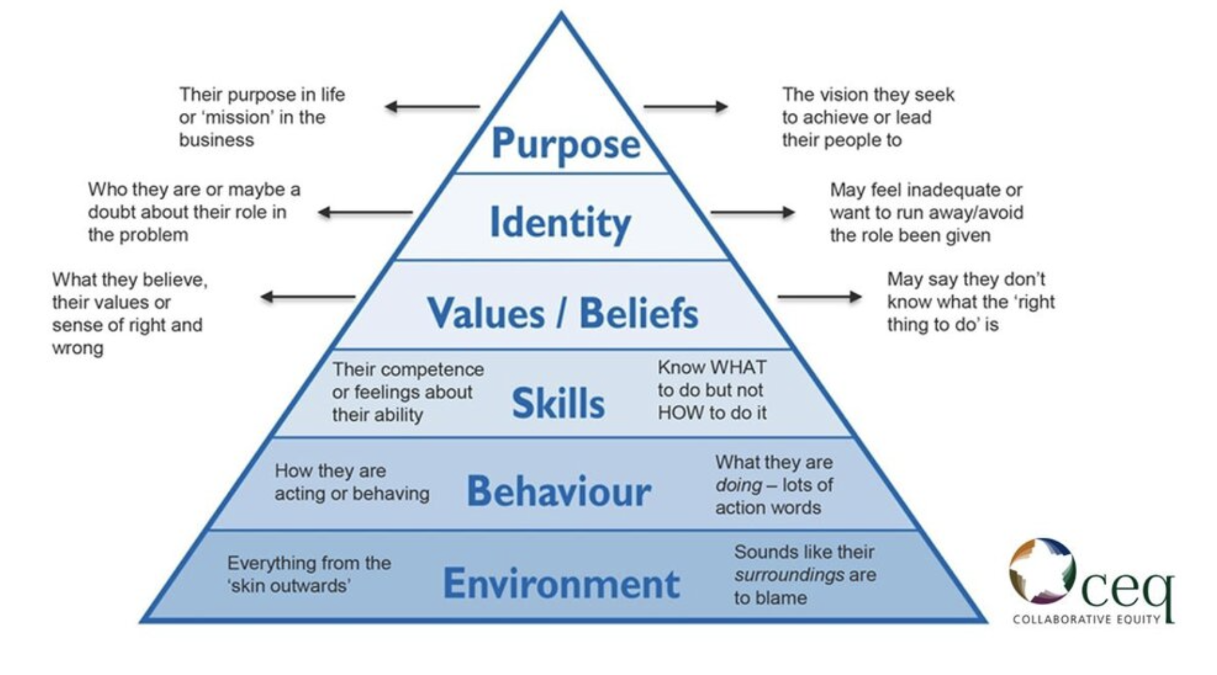
The mental environment-> behavior -> skills -> values / beliefs -> identity -> purpose

If you work on the mental environment, then you affect everything else.

Creating Narratives

Narrative -> narrow -> create systems of control, 2, walls and then drive down that path, it’s all either or, not a choice

Every system of control has 2 aspects that give the illusion of choice, but you are choosing the ONE THING.

- Democrat vs Republican
  - The voting system of control
  - You’re choosing to vote
- Good vs. Evil
  - The moral system of control
  - You’re choosing to have morals
- The west vs east
- America vs Russia
  - The global system of control
  - You’re choosing to participate in the global system of control
- America vs China
  - The economic system of control
- Men vs Women
  - The reproductive system of control
- Chevy vs Ford
  - You’re choosing a car
- Mercedes vs BMW
  - You’re choosing luxury
- Bentely vs Rolls Royce
  - You’re choosing high end luxury
- Messi vs Ronaldo
  - You’re choosing to support soccer
- Apple vs Android
  - You’re choosing to have a phone
- PS5 vs Xbox
  - You’re choosing to be a gamer
- TikTok vs Instagram
  - You’re choosing to be on social media
- Jay-z vs Nas
  - You’re choosing rap
- 2Pac vs Biggie
  - You’re choosing west coast east coast beef
- Fox News vs CNN
  - You’re choosing to watch bullshit

There is massive growth and confusion within.

You get the outcome you want

- Fox news has a narrative
- CNN has a narrative
- Grant Cardone has a narrative
- Andrew Tate has a narrative
- Every guru or person of influence has a narrative

The narrative is always the path in between two banks.

Point A —-- The Narrative —- Point B

If marketing is change work, one could argue that we want to convince them.

Most think that marketing is the business of conviction.

I don’t try to convince you

I change your point of view

And you convince yourself

So instead of me trying to convince Chad to stop eating oatmeal, peanut butter and bananas for breakfast, I just change his point of view on it and then he changes his own mind.

Human brains are rational things, meaning…they like to make sense out of realty.

To be rational is to make sense, to be irrational is not to make sense.

The only way I could do that is if they knew only what you know, see what you see, understand what you understand they would agree with you.

Because there is no other logical conclusion to that rational part of the brain.

And once they agree with you, they would buy from you, because their way was the right way, and their way the wrong way.

So what we’re doing is changing the right way to the wrong way, so they can come buy OUR right way.

That is what this is all about…and knowing where to get them to agree with you and how to do it.

You have to use stories, analogies, and insertions into it. These are forceful ways, if we try a forceful way, we are going OUTSIDE IN…and if we go OUTSIDE in…they will reject it.

All change is from WITHIN, so you have to IN the mind to change the mind, you can’t go outside of the mind to change the mind.

So all change is INSIDE OUT.

If we try to convince or argue externally, we won’t do much good.

So therefore, every argument is THEIR argument, NOT OUR ARGUMENT.

Once you do this…you start to get them to argue with themselves, and you support the side that favors YOUR outcome.

The 1st base is interception, the 2nd base is meaning, the 3rd base is story, analogy, allegory.

I love analogies, because they shortcut the thinking process.

So if you think about stories, analogies, and allegories, they exist to help the brain save energy and create meaning.

Most of the time people had to use their bodies to feed, so the brain didn’t have all day to just sit and think.

The brain has this NEED for explanation. Without explanation, it can’t make sense of the world or be safe.

When you change how people see things, then they see what you see and they agree with you, that leads to conviction, which leads to conversion.

The way you have conversions is to have conviction, the way you have conviction is to have them agree with you the way you have them agree with you is to see what you see.

What I see is true, and therefore I am convinced this is true, so I am a convert.

In essence conversions is about creating CONVERTS.

What is the best selling offer of all time? The Bible.

When you change how someone sees something, you change the value that something has.

Two people goto to a room and one goes crazy. One becomes enlightenment, what’s the difference? One has a point of view, and he wants that outcome, the other one does not want that outcome.

One went to a buddhist monastery. One went to jail.

They will allow porn, whatever on twitter and YouTube, but they will NOT allow people who can change the point of view.

The most dangerous people on earth these days to the powers that be, are the ones who can change the point of view.

- Tate got banned because he changed the point of view on men's place society
- Joe Rogan got attacked because he changed the point of view on the vax
- Alex Jones got attacked because he constantly tried to change the point of view
- Donald Trump is being attacked 24/7 because he’s changing the point of view
- Elon Musk is now being attacked by changing the point of view
- ADL on twitter is attacking Twitter itself by changing point of view
- Tucker Carlson is being attacked by changing point of view
- Candace Owens is being attacked because she’s changing the point of view
- David Grusch because he’s changing the point of view on technology

If you have faith, then challenge it. If it’s true, it will prevail, if not true, then you’ll grow.

Trump etc…all the ones that got banned attempt the point of view process, so it must be done subtly.

If you change the point of view overtly, the system will attack you. So you must do it very subtly.

You need to do two things well. One learns to communicate (write, speak, etc), and learn to sell. When you learn to sell, you are learning to convince people, when you learn to convince people you learn to change their minds, when you learn to change their minds you learn to change their point of view, when you learn to change their point of view, you learn to interpret new things.

Interpretation of something -> point of view

In order to change someone's point of view, all you have to do is change how their brains interpret that point of view, and once you change that interpretation, it can no longer have the same point of view.

There are many different things you can interpret to change the point of view.

Interpret why they have a problem
Interpret why nothing has worked for them
Interpret why their age isn’t suited for the problem

Interpretation is to change the meaning by re-explaining it to them.

When you interpret something you want to put a lot of risk and danger on it.

If you look at tate, trump, jones, etc…they all do this.

You’re interpreting against and for.

1st you have to get them to say NO, then the YES becomes automatic.

You can’t pull a belief OUT…because it KNOWS you’re PULLING IT OUT.

So you have to loosen it up..so it falls out on its own.

Deletes -> Distorts -> Generalizes -> TRUTH -> IDENTITY -> SOCIAL ASSOCIATION AND VALIDATION -> COMMUNITY (environment)

COMMUNISTS = control the environment

Copywriter = community
- These guys think copy is everything
High-Ticket Closer = community
- These guys think that high-ticket is everything
Funnel Hacker = community
- These guys think funnels are everything
Christian = community
Muslim = community

Each one of these communities has a point of view that binds them.

I am a _______________.

I am a part of the EGO.

Meta Views

- Religion
  - Muslims become Christans and vice versa all the time
- Society
  - People join and leave societies all the time
- Anything
- Can be changed

How do we know it can be changed? Because people convert all the time to something else.

Once the brain accepts something as TRUE (a new point of view) it automatically STOPS looking for anything else to counteract that truth, this is why things just get accepted and you have status quo.

To kick the market off, you have to kick off the status quo.

Status quo = is how things are = how things are INTERPRETED AS TRUTH.

perspective

The more WHO”S in perspective, the more that perspective will be universally adopted.

It’s ultimately a reframe of what it is and what it’s not.

“Truth be told it’s always ok to cheat on your girlfriend because you never let a girlfriend stop you from finding you a wife”

“Truth be told it’s always ok to cheat on your boyfriend, because you can never let a boyfriend stop you from finding a husband”

“Truth be told, it’s always ok to quit your business, because you can never let a failing business stop you from becoming rich”

“Truth be told, it’s always ok to stop being a copywriter, because you can never let being a copywriter stop you from becoming a great marketer”

We are changing the interpretation of “When is it ok to__________”.

That is BIG

Distrust (difference of point of view) -> Disagreement (difference of point of view spoken)-> Interpretation -> Point of View Change -> Agreement -> Trust

Rapport Formula

- Have things in common
- Have the same point of view in common
- Have the same interpretation of things in common

They all have a bias that they want to change, they secretly want to change this perception.

Deletes -> Distorts -> Generalizes -> TRUTH -> IDENTITY -> SOCIAL ASSOCIATION AND VALIDATION -> COMMUNITY (environment)

You interpret it in a way that has new possibility to go high emotion

And no possibility for low emotion.

Who controls point of view controls the world.

Elon Musk did not buy Twitter.

He bought the worlds biggest point of view engine in the world and he is unstoppable, so no one can fuck with him.

Let's look at some other point of view engines:

- Cnn
- Fox news
- Twitter
- Facebook
- TikTok
  - Isn’t it interesting that the US govt views tikTok as a threat? Why, because it can change the point of view

Because “their way is the right way”.

The basis of point of view is “this way, is the RIGHT way”.

The church used to have enormous power, because their way was the RIGHT way.

Surface level (unconscious)

Every leader, power tries to propagate their word view. And they do this with their point of view.

The more you try to propagate it,

There are layers of point of view.

Philosophical
Religious
Societal
Systematic

And the higher up controls the lower down.

The word view is controlled by point of view.

The world is flat = world view, you don’t go far you fall off the edge.

The world is round = world view.

The world is the center of the solar system = world view.

The more influence you have over people, the more you get them to adapt your world view, and you do that by point of view process.

So in marketing all we're doing is trying to market our world view and then this is done through POV process.

What you do is you get other people to ADAPT your worldview than ENFORCE it, and that’s when you got it.

So say you wanted to sell education, or mastermind or something higher up.

You change the point of view that education is key, so you use a STORY such as Ray Dalio that the currency of the country is correlated by the education level of the country, then innovation starts, so you link that up and you change the point of view.

BUT then you change the interpretation / point of view of education and say…regular education isn’t good - delete/minimize education , and then once you delete/minimize it, what follows is replacement. And give reasons why.

System of control = 2 options

- Normal education
- Self education via my mastermind -> buying your shit

DELETE -> DISTORT -> GENERALIZE

TRUTH - conscious - aware
Generalize - conscious - manual
Distort - subconscious - semi automatic
Delete - subconscious - automatic

Minimize -> Maximize -> Simplify

BUT then you change the interpretation / point of view of education and say…regular education isn’t good - MINIMIZE education , and then once you MINIMIZE it, what follows is replacement VIA MAXIMIZATION. And give reasons why.

This logical thing will make sense, then you hit them with an emotional layer (which they care about) and they respond to it via anger or any other emotion.

When you have an emotional response to something, it accelerates deletion/ minimization A LOT.

IT CANNOT / WILL NOT DELETE FEAR OR IT’S COUSINS. IT CAN’T. = SURVIVAL EMOTIONAL ALWAYS STAY.

WHY
- PRESUPPOSITION
  - SUPPOSES SOMETHING IS TRUE
    - WHEN BEING STATED
- ASSUMPTIONS

WHY, because this causes the 90 second emotional spin.

If you can hold the brain in ANY state for 90 seconds, it’ll remain in that state.

Why is it that they’ll never teach you the rules of the law? Becuse, they want you to fuck up so the system works, that’s how the system thrives.

- Answers questions
- Reflects on statements as true / false
- Listens to stories

Do you know why they never teach you the rules of the law? Because they want you to fuck up so the system works, that’s how the system thrives.

Here’s why they never teach you the rules of the law? Because they want you to fuck up so the system works, that’s how the system thrives. = TRUTH

The color blue is the best color, because Brad Pitt wears it. = TRUTH

Tacos are the best food, because all ferrari owners eat tacos. = TRUTH

The best copywriters all do ______________, because ____________. = TRUTH

Or it’s something they have to expend energy on.

Identity Close

All products are bought for a function, mostly to affect who they are.

When you use the identity close, if they say NO…they’re not rejecting the product, they’re rejecting themselves.

While they can reject the product, they’ll NEVER reject themselves, so this is an inversion of negative admittance.

So if they reject the project, they reject themselves.

Here’s what it looks like:

As long as you’re one of the first 300 women who order today, you’ll receive your jar of Age Brilliance.

…and not only that, but the cost of shipping right to your doorstep is covered too. You don’t pay anything for delivery!

And even though we’re holding your Jar of Age Brilliance, the only thing we can’t do is hold it for long.

The first time we did this, we sold out within a week

So if you’re someone who’s _______________ and if you’re someone who’s ____________ and if you’re someone who’s ______________.

So if you’re a woman who’s _______________ and if a woman who’s ____________ and if a woman who’s ______________.

Then you’ve already made the decision, otherwise you wouldn’t have read this far.

So let’s take everything we’ve just said about how you’ll __________ and you’ll __________ and you’ll _______________ and lets make it a reality for you.

–

Part 2 Continue (9-21-2023)

Mindset:

There’s a lot of mindset stuff, goal setting out there and books written about it.

And yet very seem to make it work.

I started to look at what goes on in the mind when we set goals and why it doesn’t work?

So goal setting and visualization blah blah blah, never works.

Goal setting in itself violates the principle of ecology.

The ecology of the mind.

You can’t have any loss. You can’t sell loss to a mind you can't motivate a mind by loss, etc…

Loss is the seed of all negative emotions.

When you’re setting goals, you’re thinking about GETTING something, GETTING somewhere.

I want to OWN a Lambo, I want to OWN a $2m house, I want to GET TO this position in life where I’m an offer owner. I want to GET to a position in life where I’m famous.

The mind will always protect you.

It doesn’t look at where you are going to get to or what you’re going to get.

It look at if you can go beyond that.

It’s not that you can’t have it. It’s that you can’t sustain it. That’s why you don’t get what you want.

It’s not that you can’t lose weight, it’s that you can’t sustain that once you get it.

It’s not that you can’t make millions, it’s that you can’t sustain making millions once you do.

It’s not that you can’t scale an offer, it’s that you can’t sustain it.

Deeply if you think about it…any action you can do, and that you do, you sustain.

Getting water - easy.
Eating - easy.
Walking - easy.
Watching tv - easy.

All because you can sustain that.

It’s not about what you can get, it’s about what you can sustain.


Your subconscious mind will grant you any wish, but…with a catch. It has to keep you safe.

If you can’t sustain it, then what your subconscious mind grants is punishment in that case.

It’s not that you’re not strong enough to get it. You’re not strong enough to bear it.

It doesn’t want to punish you.

What you may think is success is actually your punishment.

Your subconscious mind has to deal with the punishment, not you.

So as you set goals, don’t visualize goals. Visualize keeping it and sustaining it.

Me: Wants 1MM Months
also me to me: I don't have time for your shit

The reason I know this is true is because 90% of self made millionaires went bankrupt and got it all back, because they knew they could sustain it again.

Instead of competing with your greatest enemy (your subconscious), you’re aligned with it, which makes it your greatest strength.

—

The world is competing for the wrong thing, they’re competing for attention, the problem is there are too many competing for attention so you have to compete with too many people at once and thus exert more and and more energy and at some point you will run out of energy.

So when everyone starts doing something, that advantage becomes a commodity and it’s more negative than it is positive, because it lacks contrast, which lacks awareness, which lacks attention, which lacks POV, which lacks position, and control.

Human minds tend to do one thing and one thing well…compare and spot differences and then mimic based on the positive gain from said differences.

Today, the power is in being able to control perception. Not reality, and out of that perception you can create a new reality, because the brain can not lie to itself.

If we can change the perception of things we can change the value of things.

If you look at the competition between the different religious sects, they all compete on the interpretation.

You compete on meaning = you have conflict. This doesn’t mean that.

When you compete on interpretation what you’re doing is changing the meaning, so that they can’t even compete with you on the meaning.

The brain has to make meaning, but before it can it has to interpret something.

There is too much stuff going on in reality.

The brain has a process of making sense of reality.

1st it DELETES - that is not useful. Things become completely invisible to it.

2nd it DISTORTS - it changes based on our biases, prejudices, criteria, etc…
He
- The stories people tell are distorted and the explanations they have are always distorted.
- In this change of the story and explanation, it’s doing so that they can feel safe or have status.

3RD it GENERALIZES

- It takes everything and patterns it
- This saves it energy and prevents it from having to expand energy again

Out of this = the truth in their mind is formed.

And if we market, sell, or try to “change their minds” we’ll have a real hard time fighting “against their truth” or “their version of the truth”.

What do they know to be true? (answer)

Generalized - whenever you have the word ALL, EVERYONE.

They are explanations

What is the exception to the rule?

Distort - subconscious - semi automatic

They look at their bias, mostly from THEIR experience

Delete - subconscious - automatic

What is not relevant to their outcomes / core emotions.

It 1st deletes, distorts and then generalizes.

So to reverse it, we have to break the generality, then reverse the distortion, and then undelete what was deleted.

We have to reverse the process.

1st we create exceptions to the rule to loosen it up.

–

This is on an individual level, but because markets are composed of human beings, that means this also happens on a market level, because humans share knowledge and mimic attention.

What is the generalization of the market? What is the agreed upon truth?

What is the exception to the rule?

This creates doubt.

So if someone comes in and says something…then I look for exceptions to the rule and impose it on them.

Example: This person did so and so and so…ok, here are the exceptions to the rules why it worked, and if you removed those exceptions, it doesn’t work. Show me where it did?

There is always always always always an exception to the rule, unless you’re a dark lord who can hide them better than anyone.

Think of generalizations as explanations, and if you can explain it some other way so that it COULD be true, then you started the change process.
–

If you give the reason to the brain 1st, then ask a question, it’ll answer.

If you ask, without reason, it’ll get defensive because it’ll look for a reason.

So if you just go “Hey I’m curious, why” or “Hey, I’m just wondering, why”

–

Then you have to undistort their story and explanation

- The stories people tell are distorted and the explanations they have are always distorted.
- Remove biases, prejudices, limitations, etc…

Someone might have a story of how they tried webinars and they didn’t work.

Well,

it DISTORTS - it changes based on our biases, prejudices, criteria, etc…
He

- In this change of the story and explanation, it’s doing so that they can feel safe or have status.

Then you undelete - the undeletion is the most powerful one because it changes the structure of the other two.

–

Webinars don’t work, I don’t even want to think about it.

Generalization would be - yeah I know…you probably had a hard time and most people do when they’re new, but how do you explain _________ doing $2m a month on webinars and ___________ doing $3m a month using webinars?

You have to jump in and answer for it, before it has a chance to conclude on its own.

Removing the distortion: Think of distortion as a LENS that lets you ZOOM in on things.
So they can see the WHOLE thing.

In favor of webinars:

The only explanation is they’re doing something that you didn’t do and the ONLY reason you didn’t do it is because you didn’t know of that.

Against webinars:

You know what’s really going on? Those guys use super aggressive biz-op angles and have a 50 person phone team that puts people in debt and they take advantage of them. So if it REALLY worked, you’d see more people doing it in other markets than biz-op and you wouldn't need 50 person phone teams to make the economics work.

Undelete: Once you start UNDELETING, you start DELETING the truth about the other party.

Against webinars:

Here’s something else

- Most have to spend $10,000-$20,000 to just get it working
- Most have to spend hundreds of thousands of dollars to scale
- Most get into legal trouble
- The customers are not happy, otherwise why would they need to push hardcore sales and use credit

If these facts are BAD (there is no good or bad in the mind), there is only GAIN and LOSS. If these undeleted facts are LOSS, it’s bad. If it’s GAIN, it’s good.

In favor of webinars:

Here’s something else

- You know once you get it working, you’re basically running forever.
- You don’t have to show up or do anything other than just punch a few buttons on YouTube to make sure ads are running.
- The phone team takes care of everything, you never have to do anything other than work 4 hours per week.
- You’re changing so many peoples lives when you’re exposing them to all the hope and possibility.

When you’re writing copy or doing marketing…the more you can argue against your position, the stronger you will be FOR your position.

So most get good at arguing for THEIR position, but never AGAINST, the great ones focus on getting good AGAINST their position, so no one can go against their position.

Because the mind never says YES or NO, it says YES AND NO, so you do BOTH at the same time, to have COMPLETE control.

–

Undelete - bringing new things in focus
Un distort - removing bias
Un generalize - not everyone

Transition level (in between)

Interpretation - I didn’t think of that
Point of view - I see it differently

How do you see it now?

Surface level (conscious)

- Perception - I see it now

- Opinion - I think that

- Meaning - we change meaning as marketers are

- Belief - I believe that

- Knowing - I know that

When we do change work, we not only change the mind, we change the behavior.

Because without behavior, no ACTION. No call to action.

So once you change the deep foundation of it, everything you say after becomes easily acceptable without resistance.

Once you remove this, any thought, opinion, belief, etc…goes with LESS reynad and more compliance.

–

The best way to break out is to get other peoples opinions which are point of view

The best way to make sure they don’t do that is to alienate them against others so they don’t seek their opinions.

This is why cults keep ppl from the outside and why China censors things.

America uses system of control - 2 options

Points of view can be very very very dangerous.

–

Language is the main tool most ppl have to understand the world

They use it to describe the world

Interpret the world

And make sense of the world

But they always do so from their point of view

This is why copy opening is all about them

Not us

And why point of view has change

Old languages had a description for everything

Modern language is about physical things

–

EVERY single sales letter, VSL, emails, etc…HA TO CHANGE THE POINT OF VIEW OR IT WILL NOT CONVERT WITHOUT IT.

TO THE DEGREE THAT IT’LL CONVERT IS TO THE DEGREE THAT YOU CAN CHANGE POINT OF VIEWS.

THIS IS WHY SOFTWARE DEMOS SELL THE MOST IN BIZ OP, BECAUSE THEY CAN SEE THE POINT OF VIEW SHIFT WITHOUT WORDS.

Point of View

- By basis, language has meaning
- Change the language, and you have new meaning
- Or you can change the meaning of language, to change the meaning
- Change the definition of vaccine
- Then they change the language, which leads to the change of meaning, like inflation is transitory
- What they do is interpret the language and change the interpretation of it all
- Dilution of Value
NARRATIVE -> NARROW MEANING
—

Deep Change Work - Criteria Change

This is where point of view marketing comes in.

And point of view is interpretation.

Marketing is change work, the highest change work we can do comes on two planes

- Values
- Criteria
It's interesting right, because when we accept advertising / branding. We are really accepting someone else's criteria instead of ours.
This is how we start creating rationalization in our minds.
You should own this rolex because ___. No, YOU SHOULD own it, I don't want to own it because of __.
BECAUSE -> JUSTIFICATION -> RATIONALIZATION
You should own this _________ because ____________ (ATTACH TO STATUS).

My point of view says ___________________.

Here’s what you don’t see _________________.

Here’s where your bias is _________________.

Here’s

You should own this _________ because ____________ (ATTACH TO SECURITY).

YOU SHOULD BUY THIS CAR BECAUSE ___. NO...YOU...SHOULD BUY IT, not me.
Not my criteria.

If we can change criteria and values, then we can change people.

WOW.

Once you wake up to this way of thinking. You'll quickly realize the whole world is trying to impart their criteria onto you.

--

Point of View Change Process

Marketing is change work. But what are we trying to change? The point of view, because that is the precursor of directionality.

￼

Humans are very rational even when they’re not.

So you have to have the same data (experience, skills, situation, etc…) to see what they see. So it’s impossible. So if you disagree, you lose them. You have to pace them and then change it.

So they’re irrationally rational.

The brain:

1. Deleted
2. Distorts
3. Generalizes

The words, sentences, thoughts, stories, myths and mythologies are a byproduct of generalizations.

But are built on deletions and distortions.

Everyone tries to change the generalization but is met with resistance.

The change work has to take place on deeper layers which are the distortion and the deletion layer.

Once you change those, you can change the generalization and than the point of view.

You do this by changing the interpretation of how things are.

This is why you change their feelings and then you change how they see something.

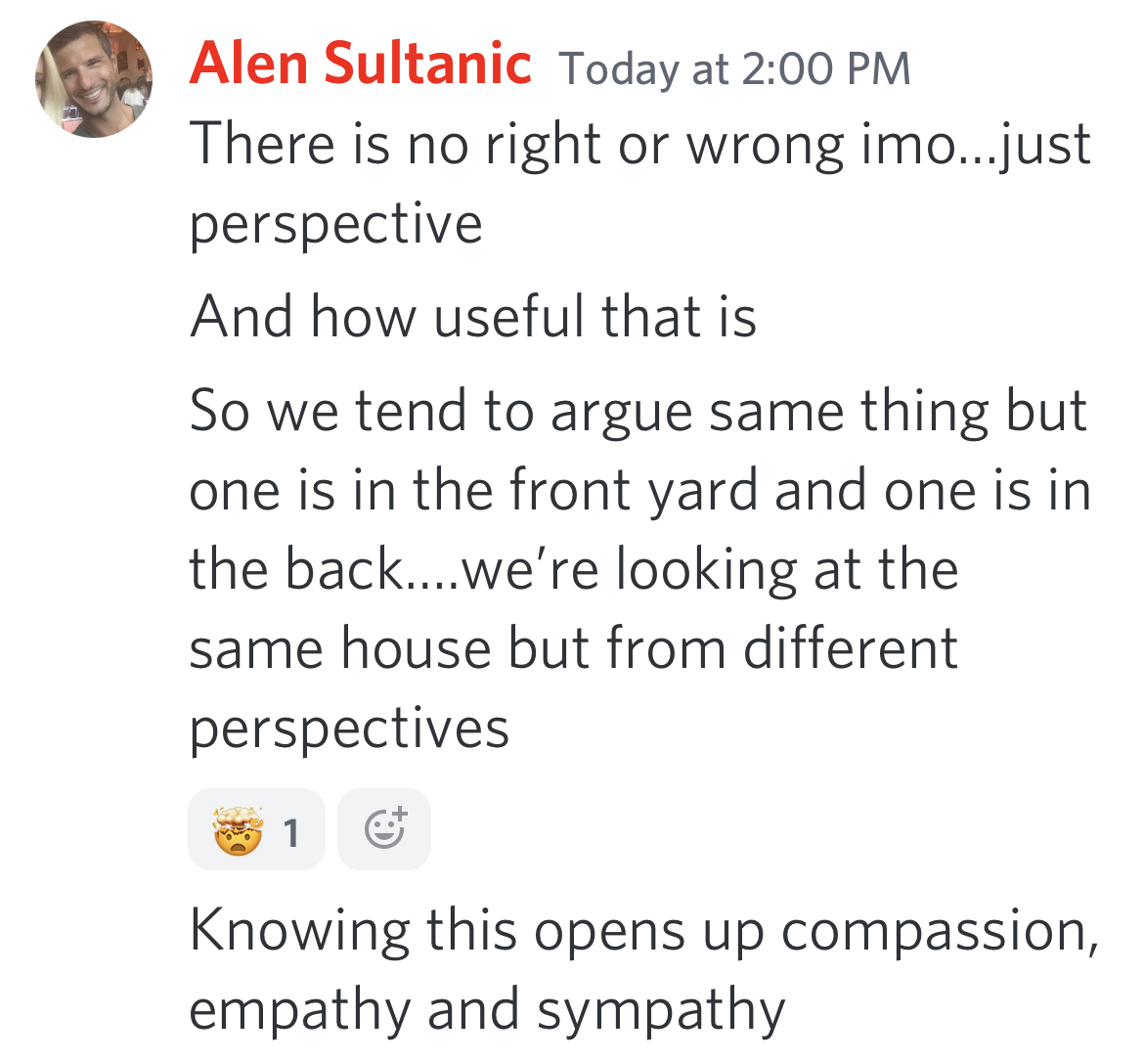

Point of view change

You need to change perception -> than you change the point of view

Direct, indirect, vicarious experience. All this builds beliefs.
https://www.ncbi.nlm.nih.gov/pmc/articles/PMC4923986/

Vicarious, read a book, etc…

You have mostly indirect and vicarious experience so most of your beliefs have no validation because you don't have any or much direct experience.

Most people in our space don’t have much direct experience.

Point of View is Controlled by Perception

Perception is controlled by what you think is true

“Nothing is true; everything is permitted”

The entire game of business is the game of perception

all profit is made in the PERCEPTUAL GAP

What you see vs what THEY see

They pay for what they don’t see and what they think they see

Introduce a little anarchy, the joker said.

The way you introduce anarchy is by making people question things, and then when they can’t get the answers for that question, there is anarchy.

Then you delete / minimize stability, create instability and then profit on selling stability again.
Define their current point of view and perspective

Define the point of view/ perspective you want them to have

What’s the philosophy to get them to the new perspective

Most of the time it’s “times have changed”. Things changed

The way you describe the change is the way you change their minds.

There’s an old way, and there’s a new way. What they’re doing no longer works, what everyone else is teaching no longer works.

–

To change who you are, change the story you tell yourself about yourself and what happened to you - Sam.
–


Generalization - they believe they need something to get something

cause -> effect

